CREATE TABLE kf_final_transaction(

product_id VARCHAR(50),

product_name VARCHAR(200),

product_category VARCHAR(15),

price INT4

)

CREATE TABLE kf_inventory(

Inventory_id VARCHAR(200),

branch_id INT,

product_id VARCHAR(50),

product_name VARCHAR(500),

opname_stock INT4

);

CREATE TABLE kf_kantor_cabang(

branch_id INT4,

branch_category VARCHAR(50),

branch_name VARCHAR(100),

kota VARCHAR(100),

provinsi VARCHAR(100),

rating FLOAT8

);

CREATE TABLE kf_product(

product_id VARCHAR(50),

product_name VARCHAR(200),

product_category VARCHAR(15),

price INT

CREATE TABLE kimia_farma.tabel_analisa AS

SELECT

  kft.transaction_id,

  kft.date,

  inv.branch_id,

  kkc.branch_name,

  kkc.kota,

  kkc.provinsi,

  kkc.rating AS rating_cabang,

  kft.customer_name,

  kpd.product_id,

  inv.product_name,

  kpd.price AS actual_price,

  (kft.discount_percentage*100) AS discount_percentage,

  CASE

    WHEN kpd.price <= 50000 THEN '10%'

    WHEN kpd.price BETWEEN 50000 AND 100000 THEN '15%'

    WHEN kpd.price BETWEEN 100000 AND 300000 THEN '20%'

    WHEN kpd.price BETWEEN 300000 AND 500000 THEN '25%'

    WHEN kpd.price >500000 THEN '30%'

  END AS persentase_gross_laba,

  round(kpd.price - (kpd.price * discount_percentage)) AS nett_sales,

  round(kpd.price - (kpd.price - (kpd.price*discount_percentage))) AS nett_profit,

  kft.rating AS rating

FROM

  kimia_farma.kf_final_transaction kft

JOIN

  kimia_farma.kf_inventory inv

ON

  kft.branch_id = inv.branch_id

JOIN

  kimia_farma.kf_kantor_cabang kkc

ON

  inv.branch_id = kkc.branch_id

JOIN

  kimia_farma.kf_product kpd

ON

  kpd.product_id = inv.product_id

;

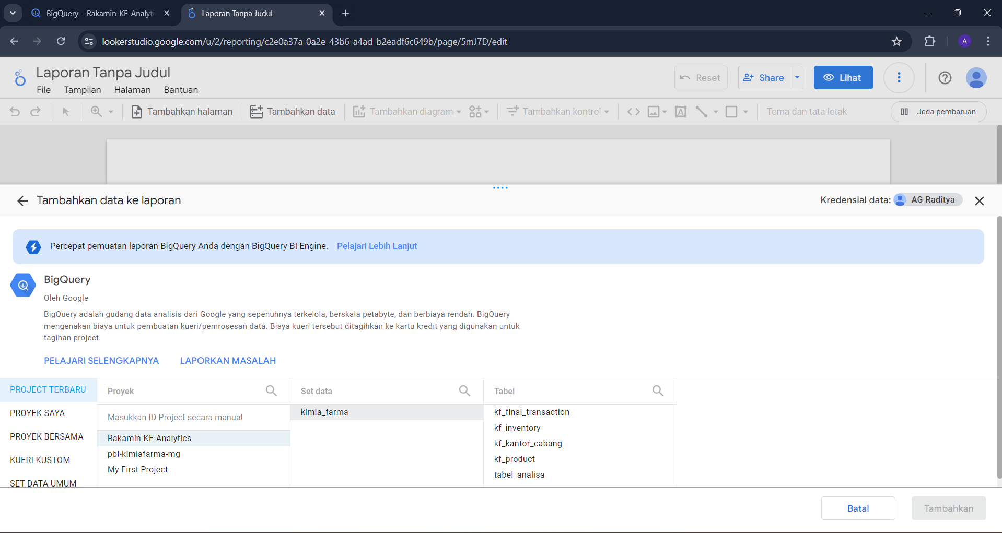

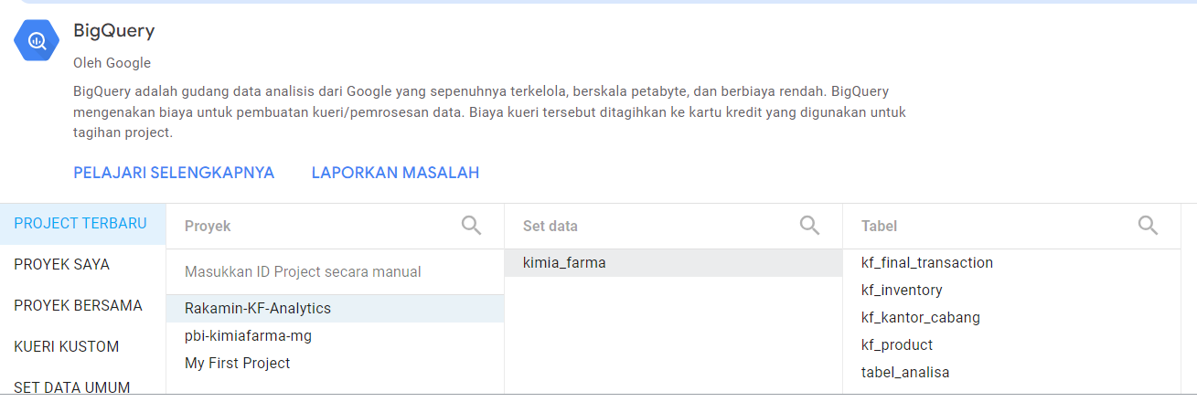

CREATE TABLE rakamin-kf-analytics-430814.kimia_farma.tabel_analisa AS

SELECT

  kft.transaction_id,

  kft.date,

  kkc.branch_id,

  kkc.branch_name,

  kkc.kota,

  kkc.provinsi,

  kkc.rating AS rating_cabang,

  kft.customer_name,

  kpd.product_id,

  kpd.product_name,

  kpd.price AS actual_price,

  round(kft.discount_percentage*100) AS discount_percentage,

  CASE

    WHEN kpd.price <= 50000 THEN '10%'

    WHEN kpd.price BETWEEN 50000 AND 100000 THEN '15%'

    WHEN kpd.price BETWEEN 100000 AND 300000 THEN '20%'

    WHEN kpd.price BETWEEN 300000 AND 500000 THEN '25%'

    WHEN kpd.price >500000 THEN '30%'

  END AS persentase_gross_laba,

  round(kpd.price - (kpd.price * discount_percentage)) AS nett_sales,

  round(kpd.price - (kpd.price - (kpd.price*discount_percentage))) AS nett_profit,

  kft.rating AS rating

FROM

  rakamin-kf-analytics-430814.kimia_farma.kf_final_transaction kft

LEFT JOIN

  rakamin-kf-analytics-430814.kimia_farma.kf_kantor_cabang kkc

ON

  kft.branch_id = kkc.branch_id

LEFT JOIN

  rakamin-kf-analytics-430814.kimia_farma.kf_product kpd

ON

  kft.product_id = kpd.product_id;